Pradines  (Saint André de Roquelongue)  20 Pradines le Haut, Domaine De Pradines,  11200  St André De Roquelongue  Aude, France  Tel +33 (0) 4 68 45 66 90 | 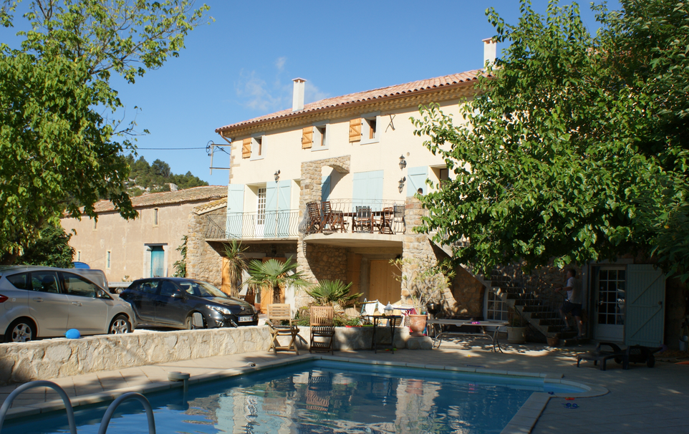

Welcome to our French holiday home.

We wish you a happy and relaxing stay!

Please make yourselves at home and we suggest that you read this 'Guest Guide' through to make the best of your stay. There are many aspects of living here that might be different from the norm (sceptic tank, swimming pool, local climate etc) that need some explaining. There are also lots of ideas of things to do in the area.

We bought the property in late July 2010 (and refurbished it in 2011) and although we have only been here a short time we have already fallen in love with both the house and the local area.

Index
- Arrival
- Guide of the Property
- Departure
- Shopping
- Restaurants/Bars
- Emergency telephone numbers & other local numbers
- Local Things to do

Arrival:
Timings: Please arrive after 4pm to enable us to clean the property after the previous guests. If you need to arrive before, please check with us in advance. We do not operate a ‘meet-and-greet’ service, but instead have provided everything you need to know below and we, or the caretaker (Ron), are on the end of the phone if you have any questions.

Access: The keys will be waiting for you in a safe box located outside on the ground floor to the left of the garage doors (see photo). It needs a combination code which will be sent separately by e-mail. These are your first set of keys and waiting for you on the table in the kitchen will be a second set. | 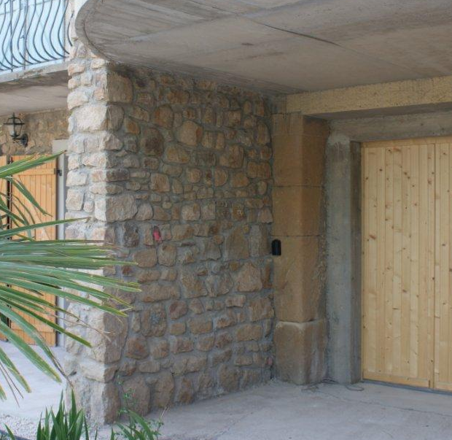 | 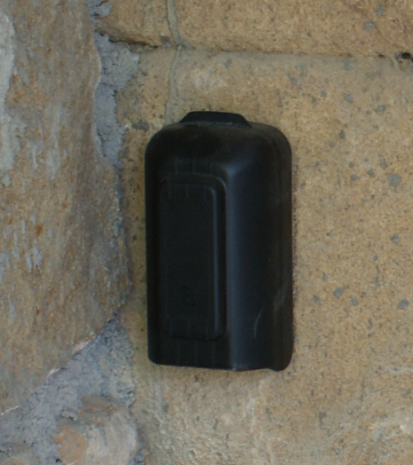

Please do not forget to return the first set of keys to the safe box when you leave (or the next guests will not be able to get in!).

Parking: There is room for one car in the garage and 3 more in the garden / drive.
Caretaker’s / Pool Cleaner’s Details: (if you have any questions / problems)
Ron: He is Dutch and speaks excellent English. He calls on Wed and Sat to clean the pool / terrace area.
Calling from France 06 61 53 66 24
Calling from UK: 00 33 6 61 53 66 24
Or failing that try us on +44 759 502 4940 / +44 208 755 4904
NB: Remember: from an English mobile, you dial 00 33 and remove the first “0” to reach a French number.

Guide of the property and its contents

A few key basics before the full details........
- Loos: Like most rural French houses there are no mains drains, and it operates on a sceptic tank system. The tank is a small one and, to avoid blocking it up, we would be most grateful if you made every effort to use only small amounts of loo paper (please highlight this to your children too). Please only use basic paper (the cheap recycled ones are best) and not the thick quilted stuff. Nothing other than loo paper should be flushed down the loos; for anything else, bins are provided. Only special cleaner can be used and this is provided in each toilet.
- Wind: The region is famous for its wind as well as sun (as you probably guessed from the large number of wind farms). The wind is a welcome relief from the high summer temperatures although you have to beware of things blowing away and windows / doors slamming if not secured. Please always keep open windows, doors and shutters secured or jammed. If a door / window does slam and break the glass, I am afraid we will probably have to pass on the bill. Please take down the garden umbrellas when not using. .
- Heat: To keep the house cool on hot days, it is best to keep the shutters drawn but slightly open on their latches (to let the air circulate) during the day and then open the windows and shutters at night.
- Pool: We have a pool cleaner who comes twice a week and the filter system, which is on a daily timer, will clean anything floating on the surface. However, leaves will blow in and sink so if you prefer a spotless pool to swim in please feel free to use the nets by the side to scoop. Please also top it up from time-to-time with the hose (up to the black tapped line). Please do not remove any chemical containers (they should be attached by string to the pump unit). If many people use the pool soon after putting sun lotion on, it can block the filter (with the risk of the pool water turning green!). Please no glass things on the pool terrace.
- The Birds: From time to time it may be necessary to hose down the pool patio area under the tree (to clear up some bird mess) in between cleaner visits. There is a broom there to help.
- The hose. This brings us nicely onto the water tap at the bottom of the outside stairs (where the hose pipe is). The tap feeds both the hose and the irrigation system for the plants. To switch the hose on/off please twist the plastic switch on the right (until it is pointing to the ground). Please do not touch the metal tap or the plastic switch on the left as this will cut the irrigation to the plants (which will unfortunately die quite quickly).
- Mosquitoes: You may get one or two coming in at night so it is advised to spray the room and yourselves with some protection. We have left some cans in the kitchen. Please use, if you do not have your own, but we would be grateful if you could replace for the next guests.
- Road past house: You can drive into the hills for a couple of miles which is quite pleasant but do not be fooled by your Sat Nav in thinking you can cut through to the other side (like we were!). It is a rocky path at best and not a road suitable for non off-road cars.
- Things to bring with you that are not provided: All bed linen and towels are provided but please bring beach towels.
- Planning: There really is so much to do in the area so we would really recommend before your visit that you check out the notes below plus the web pages on our personal website http://saintandre.yolasite.com/claudines-top-days-out.php .
- There is a no smoking policy inside the house but outside is fine (but please be careful due to the high fire risk).
- Garage: Open up the garage and there are (amongst other things) two mountian bikes (it’s a 5 minute ride into Saint Andre to pick up the bread!), a table-tennis table, all the sun-lounger cushions, a boules set and some tennis racquets.
- Ron, the maintenance / pool guy will be visiting twice a week to clean and service the pool

Kitchen:
The kitchen is fully equipped with all the appliances you will need, along with cutlery, glasses, plates etc for 12 people.

Appliances:
Cooker: The gas needs to be manually lit and a lighter is provided. We are not on a mains gas supply and the gas comes from portable bottles in the larder to the left of the oven.
Gas Bottles: If it runs out, spare bottles are in the larder and a spanner is nearby. After connecting, turn the knob on the gas bottle to ‘o’ (ouvert) and don’t forget to press the black button near the valve to re-set. The gas bottles may be switched off from time to time.
Gas Oven: This is switched on by pushing in and turning the far left hand knob to the left and lighting the right hand hole at the bottom of the oven. In the left hand hole you can check to see the gas is lit. It can be a bit fiddly – sorry ! Sometimes matches work best.
Gas Grill: This is inside the oven. It is switched on by pushing in and turning the far left hand knob to the right and lighting using the lighter.
Gas Hob: The 5 knobs on the right are self explanatory, again, the lighter needs to be used.
Dish Washer: Again fairly self explanatory. There should be some spare tablets in the nearby drawer. Please replace when finished.
Vacuum cleaner: This is behind the kitchen cupboard door (along with a bucket & mop). Spare bags in the cupboard to the left of the oven.
Microwave: Self explanatory - Please cover food.
BBQ: There are 2 small BBQs either in the garage or below the balcony. (please could you clean before you leave – thanks)
Electricity:
The electric system is pretty good (for a rural farmhouse) but in the event that something does trip the system, the fuse box is located opposite the kitchen.
Water: There is a mains water supply and the stop cock (if required to switch off in the event of a leak) is in the garage on the wall under the living room (the lower of the two incoming pipes marked ‘mains water’).
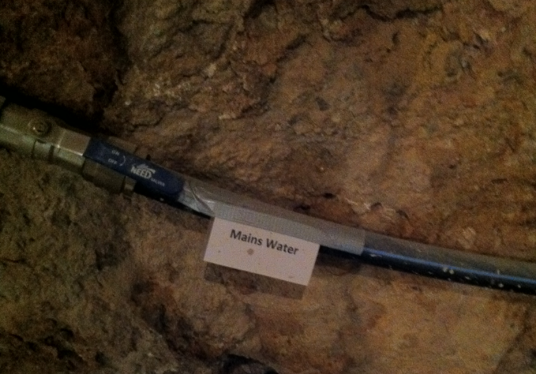
We are at the end of the line so the water pressure is a little low from time to time and does go right down whilst the garden hose is in use. (Although we have just installed a megaflow type pump, located in the owners side garage, and this seems to have helped).
Lighting: There are spare light bulbs in the cupboard to the left of the fireplace in the sitting room.
Refuse Collection: Is on Wednesday mornings between 8am & 9am. The bin is just outside the gates of Pradines to the left.
The recycle bank for cardboard, plastic, paper and glass (not cans) is on Rue de la Cooperative (from Pradines, when you get into St Andre at the main roundabout with the arch and and doors on, go straight over and it is immediately on the right). There is a wicker basket, for your convenience, under the stairs where you can put recycling materials in ready for transport.

Drainage: The comments on the sceptic tank system are covered above.

Pool Terrace:

There are 6 grey loungers (and 3 older white ones), a 3 piece rattan type garden sofa / chairs, plenty of pool toys / lilos (in the box below the balcony). Cushions for the sun loungers are in the garage. We do get a few wasps at the pool on hot days (this very common). They do not seem to be particularly aggressive. We do try to get rid of as many as possible (swatters in the kitchen!) but if you do find out where any nests are please let us know and we will get them sorted.

There are lights for the pool terrace (quite nice and atmospheric at night). One of the switches is outside, above the hose, and the lights around and inside the pool are switched on from the cupboard in the (self contained) ground floor bedroom (to the left of the door).
Garden Area: Garden furniture is left outside. Please do remember to take parasols down after use. The wind can gust up to 40/50 mph at times.

TV / Entertainment:
TV: There is a TV with HD satellite box / British Freeview channels. Switch on both the satellite box and the TV and then from the TV controller switch the source button to pick up the satellite box.
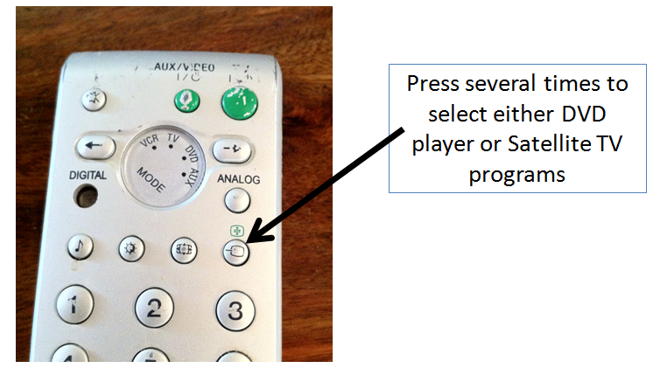

There is also a DVD Player and a small collection of DVDs although you might want to bring some of your own.
Broadband: There is a new fast 9mb line and the router / modem is in the living room. Feel free to connect your laptops / computers. Look for the ‘Livebox’ connection.

Password (all block capitals, don’t put in any gaps and ‘0’ is a ‘Zero’ rather than the letter ‘o’ !

9892 523A 3AE6 489F 27C2 053F 42
Sorry it is so complicated!

If you have any problems with Wi-Fi connection try connection to the yellow Ethernet cable. This is in one of the desk drawers if not out. There is also a printer on the desk – feel free to use. If the ink does run out, we would be grateful if you could replace.

Phone: We have just changed provider and we are now on free calls within France and other Western European countries. Please feel free to use the phone. Although please do NOT call mobiles as there is a charge there (quite expensive) which we will have to pass on to you.
Tel number for the house is +33 (0)4 68 45 66 90

There is a Hi-Fi system for CDs, a couple of radios and a speaker to connect your i-pod.
Books / Games: There is a small collection. There is also a table football, a magnetic darts board & a small basket ball net on the mezzanine level (these have helped keep our kids very happy!) but we would ask that you ensure that the balls for the foot ball table (there are only 2) are left on the table and the basket balls for the hoop are left in the basket provided. Note the net is not a sturdy out-door type so slam dunks not recommended!

Security/Safety:

Lock-up: There is little crime in the area but please lock doors windows and garage whenever you leave.
Safe Box: There is a safe box in the lounge to the right of the fireplace on the first floor. The instructions are next to it. To re-set a code, open the door, press the red button on the inside of the door and enter a 3 digit code followed by A or B. To open enter your code and twist the knob. If you forget the code there is an over-ride key in the white key box in the kitchen – check instructions on how to access.
High Fire Risk: The area is very dry and hot in the summer and there have been many forest fires. There was one very close recently and if you turn right from the house you will see the results a few hundred yards away. Suffice to say, please be very careful with cigarettes and other potential fire hazards when outside. If you are smoking on the balcony, this is fine but please be careful not to drop lighted cigarettes or ash onto the garden below. It would not take much to set the garden on fire.
Fire Extinguishers: The main one is situated in the kitchen and the other at the entrance to the living room. There is also a fire blanket to the right of the oven.
Lightening: There can be some lively thunder storms from time to time. I would suggest you unplug any expensive items like laptops in case of a strike.
Toddler safety gate: This is located behind the linen wardrobe at the top of the stairs.
Pool: The pool is open. Please, please watch out for your kids who cannot swim.

Local emergency numbers:
Doctor: Doctors’ practice situated in Saint Andre de R - Dr Salsou and his wife Dr Lapasset, tel 04 68 45 11 99
Dentist: Nearest dentist is the neighbouring (10 mins) town of Bizanet, Dr Richard Bertin, tel 04 68 46 93 54
Nearest Hospital for A+E: Narbonne city centre on Bvd Dr Lacroix. Centre Hospitalier de Narbonne‎, mobile call out also (S.M.U.R), tel, 04 68 42 60 00‎. English speakers available. Open 24 hours.
Emergency Services:
General 112
Medical help 15
Firemen (Pompiers) 18
Police/Gendarme 17

AOB:
Cleaning: The property is cleaned between each set of visitors, however we would ask that, as far as possible, you leave the property as you found it. If for whatever we need to do more than a normal clean through, then we reserve the right to make a charge for this additional work.
House Contents: We understand that occasional breakages will be unavoidable but would be grateful if you could make arrangements wherever practical to please replace any broken item.
Mobile Reception: You can pick up a signal by the front door or the second floor (sometimes) or more consistently by the left hand corner of the pool terrace.
Food. If you are arriving on a Saturday, it is worth doing a basic shop (on Saturday) to keep you going. Most shops are closed all day Sunday. The local shop (Vival) is open Sunday morning and closed all day Monday. We always try and stop off at the motorway service stations en route from the airport when we arrive. They have a fantastic choice of food.

On Departure:
Check out time is 10am on Saturday. I hope this does not rush you but it takes 2 people around 10 man hours to clean such a large place and the next guests will be arriving at 4pm.
We would be very grateful if you could do the following.........

- Empty the fridge and cupboards of any perishable foods you have bought.
- Remove all rubbish and any recyclable material from the property
- Make sure everything is switched off and all taps / gas firmly closed
- Clean BBQ if you have used it.
- Please leave the property tidy and in a reasonable state for the next guests
- If you have used the washing machine or dishwasher, please check it is empty before leaving.
- Please ensure that the 2 sets of keys are left. One on the table and the other back in the safe box where you found it by the garage).

We thank you for your cooperation.

Shopping: | (note most smaller shops have quite irregular hours and a long lunch break!)
General Store: Our local main local shop (mini supermarket run by Simone) is Vival, Place de la Fontaine in St Andre, tel 04 68 45 03 53. It has a nice meat / patisserie section. (Opening hours are Tues - Sat 8am to 12.30pm and 5 to 7pm, Sun 8am to 12.30pm, closed Sun pm and all day Monday). There is another good general store in Bizanet called Les Saveurs des Corbierre that has a slightly better range, about a 5 min drive from St Andre. (Summer opening times Mon-Sat 8am to 12.30 and 4.30 to 7pm. Sun 9 to 12.30)
Petrol Station: Nearest one is Dyneff (with shop) on the road from St Andre to Narbonne.
Bakers (Boulangerie): Cyril, Rue Couchet, St Andre de R , tel 04 68 45 14 83 (opening times Tues - Sat 6.30 - 12.30 and 5.3o- 7pm, closed Monday all day, Wed pm and Sun pm)
Post Office: In St Andre de R, tel 04 68 45 16 30 (open Mon-Fri 8.45pm to 11.30 and 1pm to 3pm. Sat am only. Closed Thurs PM and Sunday)
Chemist (Pharmacie): In St Andre de R, tel 04 68 45 10 53 (open Mon – Fri 9am to 12 noon and 3pm to 7.30pm. Closed Sat PM and all day Sun)
Nearest Cash point. Outside the Post Office in Saint Andre de Roquelongue.
Meat Van (Forgonette): Unfortunately the butcher has closed down (although Vival the small supermarket sells meat) but the Forgonette visits on Tues and Wed mornings and parks opposite the Mayor's office / Town Hall (Mairie) on Rue de la Marie. There is also a Fish Van that comes every Tuesday morning. There is also a van selling lovely roast cooked chicken / roast potatoes on Fri evenings located on Rue de la Marie (other cooked meats can be ordered). The Pizza van comes Wed evenings at the same place.
Hyper Market: Geant and Carrefour in Narbonne. Geant is the nearest (about 15 mins) and is just near the Narbonne West exit on A9. To get there, drive back to Narbonne and before going into the city pick up signs for the A9, (but don’t take it) Geant signs will take you from there.

Local Markets:
Gruissan: Every Monday, Wednesday and Saturday mornings in the village and Sunday morning at the Plage des Chalets.
Narbonne: Every morning at Le Plasir des Halles (covered market).
Legiznan: Farmers market every Wed morning.
Saint Pierre le Mer. Every morning by the beach.
Local second hand market event diary: http://vide-greniers.org/agendaDepartement.php?departement=11

Restaurants / Bars:
Saint Andre de Roquelongue - Le St Andre, Pizzeria, basic food but nice and local. (Open 11.30am to 2pm and 5.30 to 8pm, closed Mon, Wed, Sun Evenings)
Bizanet - 3km from St Andre, La Forge, basic food including pizzas and salads, nice street and can eat on the terrace outside tel 04 68 45 20 21. There is also a high quality restaurant, La Table du Chateau tel 04 68 93 51 19, menu is 16-21 Eur daytime and 33-36 Eur in the evenings. There is also a bar in Bizanet.
Lezignan (about 25 mins drive) this is quite lively and there are several restaurants on the main drag. Try Coco Sweet, next to Rue Pablo Neruda, which looks lovley from the outside and has a garden area. 04 68 33 65 28.
Luc sur Orbieu - 8km from St Andre , La Luciole, tel 04 68 40 87 74. Menu 15-36 Eur
Gruissan - On the coast, L'Air du Large tel 04 67 75 12 12. Menu around 20 Eur. Jazz on Saturday evenings in summer. Lovely terrace. (one guest went here in Aug 2010 but did not like very much).
The old part of the town has several restaurants where you can eat outside in the narrow lively streets
Fonjoncouse- 13km from St Andre, La Table de Saint Crescent , 04 68 41 37 37. This is a Michelin 3 star restaurant. Menu is 42-79 eur.
L'Abbaye de Fontfroide - 3km from St Andre, La Table de Fontfroide, tel 04 68 41 02 26.
Narbonne : There are 2 livelyish bars in the centre of Narbonne (near the Cathedral) called Rive Gauche (by the canal on the same side as the cathedral and in the area where they have the Sunday market) and Botafogo (nearby on the other side of the canal but have not been to this one)
Narbonne Retaurant, Ave Domitius. Great location by the cathedral. Average-priced food and good service. Can eat outside. Tel 04 68 32 33 76, 16 Place de l’hotel de ville.
Le Somail: A little further, perhaps 35 mins, but in the gorgeous canal side village, Le Somail, Auberge du Somail, 04 687 07102

Useful Numbers:
General / Tourist information:
Mayor’s office in St Andre de R , tel 04 68 45 10 86 (contact: Marise)
Bizanet, tel 04 68 45 88 03
Narbonne, tel 04 68 65 15 60

Baby Sitters: (all registered, details given by the mayor’s office)
Mme Silly 04 68 48 42 36
Mme Christine Lienard 04 68 45 96 23
Mme Lydie Benazet 04 68 48 62 33
Local guest house: Demeure de Roquelongue - (Gorgeous old house with 5 rooms), 53 Ave de Narbonne, St Andre de R, tel +33 4 68 45 63 57

Taxis:
Corbieres, 04 68 48 83 15 / 06 80 95 22 30
Taxis Corbieres‎- Ferrals les Corbières‎ 04 68 75 51 30‎
AC Taxi Jean Francois‎- Narbonne, 04 68 32 93 86‎
A.b.c.d. Narbonne Taxis‎- Narbonne, 04 68 65 55 19‎

Weather Check:
http://france.meteofrance.com/france/meteo?PREVISIONS_PORTLET.path=previsionsdept%2FDEPT11%2F20100727210000T

Local things to do:
Check our website before you visit http://saintandre.yolasite.com/claudines-top-days-out.php
Many beautiful interesting places are within easy reach. Here are a few local ideas. We have also left a selection of brochures in the entrance. Please check though but, as there is only one of each, we would be grateful if you could leave these for the next guests.
Beaches: Best are Narbonne Plage (closest, really open and spacey) and Leucate (our favourite, just slightly further). You can reserve a lounger at Narbonne Plage, (location is Maka Plage), Pierre, 06 15 40 7734.
River Swimming: Ribaute (near La Grasse – highly recommended) and in La Grasse itself. There are beach areas for sunbathing too.
Boat hire: Electric boats from the centre of Narbonne, to explore the canal that runs through the city.
Sea boats: available to hire from Port Leucate. Quai de Paurel, Bassin Sud. Tel 04 68 40 89 73, www.loca-detente@wanadoo.fr . Bikes are also available for hire from the same place.
Boat Excursions: Catamaran leaves Gruissan on short and half day cruises. Tel 04 68 49 26 25
Kayak Hire: In Puichéric (nr Lezignan), company called Eaurizon :‎ 04 68 32 04 71. 1.5 or 3 hour journeys. Thoroughly recommend! Exciting start down a water ramp, many rapids (fine for the family) and generally nicely organised.
There is also more extreme canoeing around Limoux. Someone also mentioned an adventure park in the same area.
Our favourite: Canoë Roquebrun, Chemin de la Roque, 34460 Roquebrun, 04 67 89 52 90, www.canoeroquebrun.com‎. The town itself is idealic and worth the 1hour 10 mins drive.
Sailing Boat Hire: One of the nearest is Zef Control, Narbonne Plage. They have Hobby Cats (as well as land yachts!). www.zefcontrol.com, 06 71 04 85 17.
WindClub Corbiers, Base Nautique, 1089 Port Mahon, Sigean tel 0960 181 370 / mob 06 06667842. Or
Cercle de Voile du Cap Leucate, Port Leucate, tel 09 71 37 59 32. (have not tried these yet – just googled them)
JetSkis and Banana boat tows: Narbonne Plage and Gruissan, www.jetxtreme11.com
Bike Hire: Our favourite is Mellow Vellos, 3 Place de L’eglise, Paraza. Phil +04 68 43 3821 / 06 50 50 01 49. Great views / flat rides along the Canal. Also Homps (both are on the Canal du Midi) – 40 mins drive. Half day 15 Eur, tel 06 37 07 05 00.
Go Karts: Plenty of places....Nearest is Sunkart, Route de Narbone Plage, Gruissan Plage, http://www.sunkart.com/ tel 04 68 49 95 20 (on the D322 from Grissan to Narbonne Plage, opposite les Ayguades). It is 13 Euros for 9 minutes
Also 2 near Agde (about 1 hours drive) , 1/ Go-carting Number One, La Tamarissière, Agde http://www.kartingnumberone.com, tel 04 67 21 05 97 (we have tried this place and it was great fun, they ave junior and senior karts and quad bikes (also fine for kids).
2/ Karting de Marseillan‎. Not been to, has a larger circuit by the looks of it. Chemin de la colline du Prieur
34340 Marseillan Plage, Agde , 04 67 01 65 06, ‎http://www.kartingdemarseillan.fr
Also at Carcassonne, by the airport, Win Kart, Route de Bram, tel 04 68 25 67 07 min age 7 yrs €13 for child, €16 for adults. (we have not tried this yet). http://www.winkart.fr/WinKart/Accueil.html
Local walks: You can turn right outside the house, then first right after 100 yds and head up the hill. Plenty of choice and good views. Our favourite is a walk up the East side of the Roquelongue – (the long rock nr St Andre). Drive to Montseret, turn right at the cemetery. Lovely walk and views and some castle ruins at the top to boot.
Abbey de Fontfroide: www.fontfroide.com, tel 04 68 45 11 08. Very close - on the road (D613) to Narbonne from St Andre. There are also a few walks from the abbey up into the hills (highly recommended).
Le Parc Australien : Carcassone, A61 exit 24, follow ‘La Cite’ then ‘Montlegun’ and ‘Lac de la Cavayere’ (see below)
Carcassonne Plage: (also known as ‘Lac de la Cavayere’, directions above. See the Pradines web site too. This is a must visit place. Lake for swimming, Zipwires Parc (02 Aventure, 04 68 25 33 83, www.02aventure.com), Water Park (www.parcaquaviva.com) , walks , stunning views.
Aquatic Parc: Narbonne Plage. Aquajet Parc, Route de Gruissan, tel 04 68 49 33 61. Lots of flumes, cafes, swimming area. Fun family day out.

Pretty Villages to visit:
Peyriac de Mer: Lovely old village on coast towards Sigean. They have a Brocante (Car Boot type market) on the first Sunday of every month.
Port Leucate: There is a hive of activity including an Outdoor Adventure Park (family fun, trapeezing over river etc) tel 06 10 04 58 50 www.leucate-aventures.com , 4 yrs plus (best to wear trainers), a Water Ski Cable tow http://www.teleskibarcares.com/ tel 04 68 86 23 45, an Aqua Park (water flumes etc), bike hire and a long beach.
Le Somail, (on the Canal du Midi) a 17th century port with lovely arched bridge over canal. Cafes, restaurant and hire of electric boats for 22 euros per hour. Head for the port when in the village. Only half an hour drive from Pradines. It is NW of Narbonne on D607, Narbonne to Ginestas road. When you head towards Narbonne on usual road in after passing under motorway, go straight at second roundabout, not right into Narbonne as usual, direction Marcorignan).
Chateau de Ventenac : at Ventenac enMinervois. Lovely spot on the Canal du Midi with restaurant and Winery, tel 04 68 91 25 89.
The local places considered officially as ‘Plus Beaux Villages’ include Castlenou, Minerve, Saint-Guilhem-le-Desert and last (but not least, and the closest) Lagrasse.

Festivals: Spanish week is held in the last week of August in Carcassonne see ...... http://www.carcassonne.org/carcassonne_EN.nsf/vueTitre/docVisiterSemaineEspagnole?opendocument&EN&Visiter&Les%20temps%20forts&32&Les%20temps%20forts
And, around the 11th- 15th August in Bézier, there is a “Féria” where you will see bull-fighting (both of the traditional type with well-known Spanish Torredors or, the harmless one involving men on horse-back placing rosettes on the bulls) . At the end of July, there is a music festival in Lagrasse.
Christmas Eve in Narbonne centre is quite a spectacular carnival atmosphere.

Rainy Day Activities:
Cinema: There is a multiplex in Narbonne near the Geant / A9 exit - Cinéma Mega CGR‎,, ZI Croix Sud, Route de Perpignan, tel 08 92 68 85 88‎. There is also a chocolate factory in Narbonne. (yet to get details).
Swimming Fun: Espace de Liberte, Water Slide, pool, bowling and ice rink. http://www.espaceliberte.com tel 04 68 42 1789

Sport:
Tennis courts are available to hire in the centre of Saint Andre de R for 8 eur per session. You book and pay M. Loie Malard, 8, Chemin des Gayettes. (From the main through road in the village to our house, this street is the one that is directly opposite the one the Marie’s office is on) tel. 0468 42 43 70.
Mini (Crazy) Golf: Domaine de la Source. Very close - On the road (D613) to Narbonne from St Andre. www.jemmes.com, tel 04 68 42 14 46
Nearest Sports Centre: Narbonne : (no details yet)
Horse riding: Narbonne, tel 04 68 49 47 83, www.tournebelle.com
Bike Hire: Narbonne also Port Leucate.
Quad Bikes / Off Road: At Chateau de Lastours near Sigean. Hire or get guided tours of the hills. tel 0468 48 64 74 http://www.chateaudelastours.com/
Winter skiing: Nearest resorts are in the Pyrenees and are about 3 hours drive, include Font-Romeu. Les Angles and Cerdagne-Puigmal

AOB:
Neighbours:
Stephane – In the house behind Pradines. He is not there all the time. Stephane speaks OK English.
M. Chenerey, lives in the large Chateau looking building to the left. He is there in the summer months.
Detliffe and Myriam. Detliffe is German and speaks good English. He is the owner of the barn to the right and all the vineyards surrounding Pradines.

And finally...........
We really hope you enjoy your stay – if you experience any problems, please do not hesitate to contact our caretaker or if you prefer ourselves.

If you have enjoyed your stay as much as we do when we visit, please let your friends know.

Chris and Claudine

Directions (as per web page entitles ‘Directions)

Suggest you look at the web page which has more detail / some pictures for the bit from Saint Andre
Directions from the A9 (e.g from Beziers or Perpignan)
- From A9 take exit 38-Narbonne-Sud toward Saint-Jean-Saint-Pierre
- Through Peage and remain in central lane, continue straight onto D6009 (signs for Perpignan/Carcassonne/Lézignan) 2.6 km
- Take the ramp to D6113/Narbonne-Centre/Carcassonne/Montredon-des-Corbières/Lézignan-Corbières 260 m
- At the roundabout, take the 1st exit onto D6113 heading to A9/Carcassonne/Perpignan/Sigean Lézignan-Corbières 2.9 km
- At the roundabout, take the 3rd exit onto D613 heading to Bizanet, head into hill, pass quarry on the right, pass under A9, 11.3 km
- After long straight bit turn left sp to St Andre de Roquelongue, D423, 1.5 km
- Go through St Andre, over a cross road, pass garage on left until you arrive at a large roundabout (the only one in Saint Andre!)
- Take 3rd Exit, (Cave Cooperative on right) Le Coude / Pradines (on Route des Pradines)
- Go over bridge ,
- Turn right at fork signposted Pradines Le Haut
- Stay left at the next fork (by the green box in the middle of the road)
- We are on the right as the road levels out. Look for the barrel by the entrance.

Directions from A61 (e.g from Carcassonne)

- From A61 exit, take junction 25, Lézignan toward Lézignan-Corbières
- At the roundabout, take the 3rd exit onto D611 heading to Ferrals-les-Corbières/Fabrezan
- Cross over the A61 and continue along straight road for 2.2km
- Turn left at D106. Ferrals-les-Corbières, (this is easy to miss!), 900 m , through Ferral- les-Corbierres
- Turn left at Avenue de Carcassonne, signposted Durban / Villerouge on D106
- Continue over a bridge (River Orbieu) on D106, through Villerouge la Cremade, 5.6 km
- Turn left at D611 , Thezan / Durban / Saint Andre de RoqueLongue , 1.3 km
- Slight left at D613 sign posted Narbonne / Saint Andre de Roquelongue, 6.2 km
- Turn right at D61, Saint Andre de RoqueLongue, 1.7 km
- Once in Saint Andre you will arrive at a Square (opposite a bus stop). Turn left signposted Narbonne / Montserret.
- At end of Road turn right, D423, signposted Montserret
- Over a cross road, pass garage on left until you arrive at a large roundabout (the only one in Saint Andre!)
- Take 3rd Exit, (Cave Cooperative on right) Le Coude / Pradines (on Route des Pradines)
- Go over bridge ,
- Turn right at fork signposted Pradines Le Haut
- Stay left at the next fork (by the green box in the middle of the road)
- We are on the right as the road levels out. Look for the barrel by the entrance.

